CMST 250, Hardware & Networking Fundamentals
Lab 3 – Build a DC motor

PROJECT – Build a DC Motor

This simple DC motor uses the principles of electricity and electromagnetism to do work. When electricity flows through a wire, it emits an electromagnetic field. Michael Faraday was one of the early explorers of electromagnetism who experimented with the relationship between magnets and current carrying wires. The motor we construct today uses coated magnet wire, magnets, some paperclips, a power supply, and a stand to hold it all together.

- Take some magnet wire (the bronze/orangey coated stuff) and make a motor armature by winding around a marker pen about 15-20 times. Tie it together by making some additional wraps around the armature coil, leaving two ends sticking out about 1.5 inches on two opposite sides. Your finished coil should look like Figure 1.

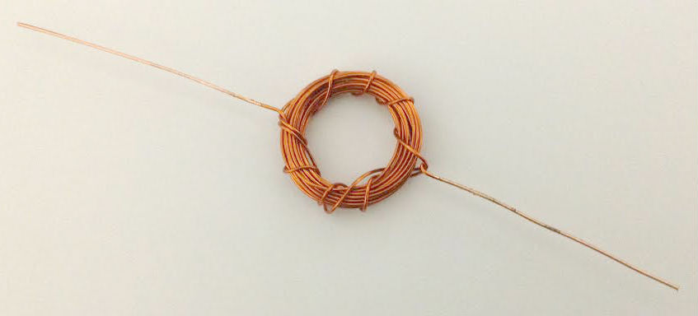
Figure 1- Completed armature
- Using sandpaper or the blade of a knife or scissors, completely scrape the insulation coating from one of the armature ends that is sticking out (it should show shiny, bare copper). On the other end, remove the insulation coating from only one side, and leave the coating on the other side (Figure 2). As your motor spins, this will allow your motor armature to conduct electricity through half of a rotation, and shut off electricity through the other half rotation. Think about this question: Why is it important for the electricity to shut off for half a rotation?
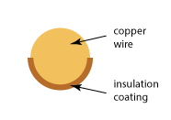
Figure 2 – Cross section of wire with coating removed

- Create mounts for your motor out of two paper clips. Bend the paper clip so it forms the shape of an “L”. On the long end of the “L,” make another small “L” shape that will hold one side of the motor armature. When finished, it should look like Figure 3. Make two of these for each side of your motor.

Figure 3 – Paper clip motor mount

- Tape your two motor mount paper clips on opposite sides of a Styrofoam cup. Arrange them so your motor armature coil can rest on them and turn freely. Tape a small magnet beneath your armature coil. Your motor should now look like Figure 4.
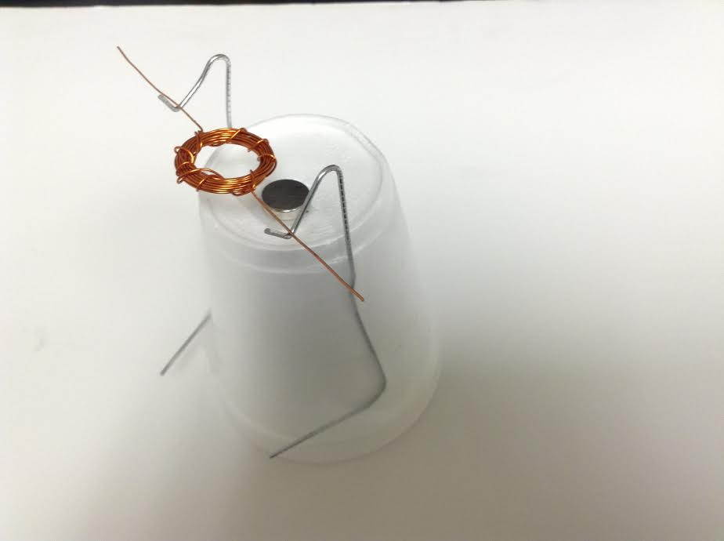
Figure 4
- Connect copper wires to each of the paperclip leads with alligator clips at the bottom of the cup. Connect the other ends of the wires to the positive and negative ends of a battery using tape. When everything is connected, give your armature a tap. If everything is working correctly, it should spin and keep spinning. You may need to double check electrical connections and adjust the balance of your armature coil to get things working.
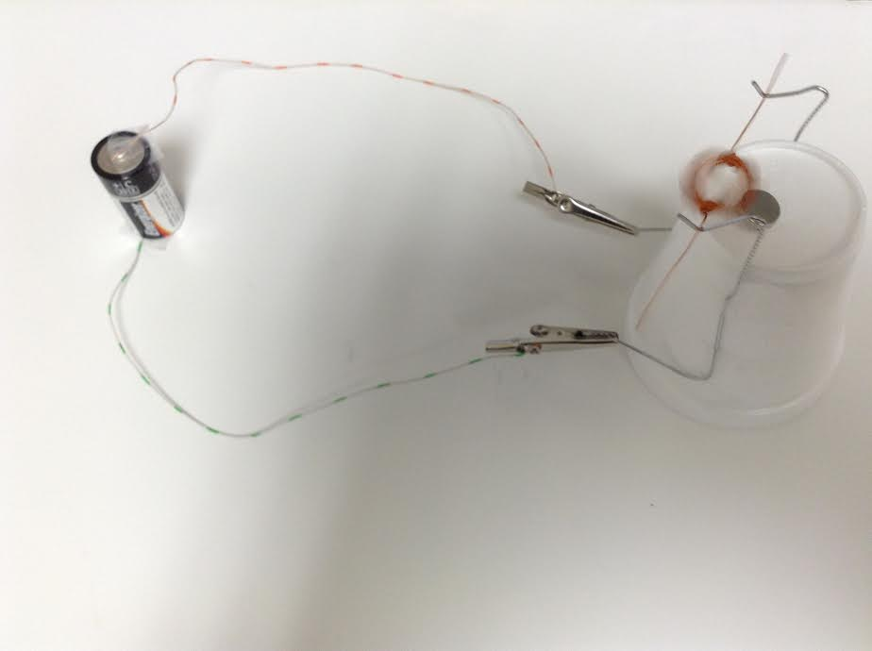

What problems (if any) did you have getting your motor to work? What did you do to fix the problems?

